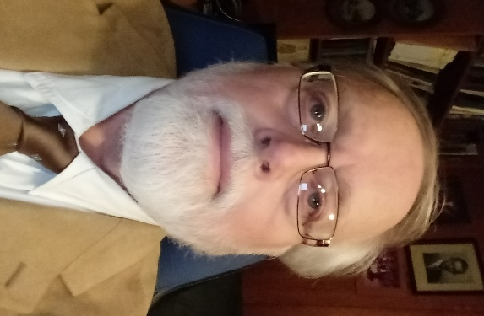

Walter P Jenkins short bio.

Walt was born in Monterey California shortly after the end of WW II. His father was a bomber pilot in the USAF and continued a life long career in USAF, retiring as a Colonel. Walt grew up in many different countries as the family was reassigned to duty stations overseas. His father retired to the Sarasota Florida area where he had grown up. Walt developed a passion for motion pictures as an art form and moved to Hollywood California, in his twenties. He spent most of the 1970’s in the film business. He developed the world’s first virtual set system for the motion picture industry and several other computer based technologies such as non linear computer based editing systems. He has designed and installed broadcast TV stations and private production and post production facilities for government, commercial and broadcast clients and turn- keyed the engineering with cutting edge technologies, some of which he designed. He managed a broadcast TV station in the Orlando Florida market during the late 1990’s
In the mid 1980’s Walt began working on alternative fuel systems for cars as a hobby. By the early 2000’s he was working on Hydrogen extraction from water , electrolysis, and trying to find more efficient ways to get fuel energy from water, than electrolysis could deliver. He soon abandoned electrolysis and created a new proprietary way to capture all of the potential fuel energy in water. Eventually, he was able to convert water to clean fuel with less than 180 milliamps of input power at 12-24 volts DC, and run engines entirely on the water fuel, a mix of up to 95% water and just 5% gasoline. More recently, he has tested 99% water fuel.
The resulting research was so successful and the technology so unique, he was in an area of research by himself. Thunderclouds, lightening, and a study of their processes led to a new discovery of extracting fuel energy from charged particles in high energy states. This led Walt to design a new energy extraction process to create fuel to run cars or any internal combustion engine, even commercial jet turbines, from energy extracted from water. Now, any internal combustion engine can run cleanly on water based energy.
Walt has patents filed around the world on the technology of creating low cost clean fuel energy from water and also on his new high plasma spark plugs. He has pioneered a new way to bring the power of lightening and thunder storms into any internal combustion engine. They can run completely on a clean water based energy or mixed with fossil fuels. This process currently, can yield up to 99% cleaner emissions while still using 1% gasoline
The newest iteration of this technology uses no fossil fuels and is a 100% clean water based fuel made from either fresh or seawater. Soon, Seawater Trials begin on a catamaran in Tampa Bay, Florida. It is being equipped to pump seawater into an H2 Global water energy conversion box, extract clean fuel energy to run the engines, and return the seawater as pristine as it was, when it entered the process.
Walt recently perfected his advanced CUBE technology which extracts water from air, “like an advanced dehumidifier” and is able to condense enough water in a day to run a big truck or Bus on his clean water fuel and travel across continents without stopping for fuel. His water fuel extends the range by a factor of 5x at a minimum and has been tested at much higher ranges, well over 100x
Walt, is also working on a new battery design based on nature, it may bring in a new form of battery much lighter in weight and with far higher energy densities.
A new form of Solar cell is now being developed by Walt which has many times the efficiency of current technology, it is on a flexible substrate and uses principles found in nature. The target is to create a low cost system with near zero carbon mfg process & turn out inexpensive high power density solar power units which do not need to rely on mining or other carbon intensive activities.
During his research into converting seawater to clean fuel, which leaves a zero toxic footprint and returns unused water to the sea as pristine as it came out, Walt designed a new desalinization process more efficient than current technology, requiring much less input energy and yielding higher output. This was necessary to the early design seawater fuel system. Later a better, newer, design did not require desalinated water to convert seawater to fuel.
Walt studied at Columbia College, Florida State University and various community colleges.

© copyright 2019 , Walt Jenkins , all rights reserved

