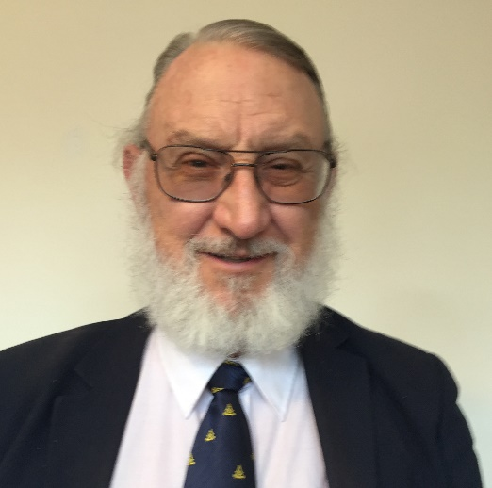
Dr. Bailey received his PhD from MIT in Nuclear Engineering.
He then was a Nuclear Research Officer in the USAF (Captain),
a Project Manager in the Nuclear Division at the Electric Power Research Institute, and
then a Senior Electronics Engineer and Manager in Electrical Power Systems at Lockheed Martin.
He is currently a Senior Member of the AIAA Advanced Power Systems Technical Committee, and has been the President of the Institute for New Energy since 1994.
He will manage our H2G West Coast Research and Sales Office near San Francisco, and will network with international energy researchers.
He also plans to use his over 25 years’ experience in Masonry to spread information about H2G technology breakthroughs to other governments and institutions around the world.

